
a
Company
Logotype

Cone Beam Computed Tomography- Report



Porur Dental X-rays & CBCT

Patient Name : Mrs. Shanthina | Date of Report : 24.04.2024
Age/ Gender : 43 years/ Female | Region of Interest : CBCT Full Skull
Referring doctor: Dr. Jasher | Indication : Implant assessment
Clinical Notes: Nil
PATIENT INFORMATION

CBCT- Full Skull provided
CBCT – IMAGE DETAILS

RADIOGRAPHIC INTERPRETATION

- Completely missing crown and root portion in relation to 24, 28, 36, 37, 46, 47.
- The maxillary alveolar ridge is present with normal trabecular pattern.
- The left maxillary sinus is present with mucosal thickening in relation to the floor of the sinus, which is dome shaped and appears to occupy more than half of the sinus volume.
- Presence of irregular hyperdense structures in relation to the periapical aspect of 35 and 36 region.

IMPLANT ASSESSMENT

 | 24 region
Sub-Crestal | 4
Mid- Crestal | 5.5
Distance between the alveolar ridge and Floor of the Nasal cavity (in mm) | 17.6

 | 36 region | 37 region | 46 region | 47 region
Sub-Crestal (in mm) | 4 | 3.7 | 5.3 | 8.1
Mid- Crestal (in mm) | 5.1 | 5.6 | 7.5 | 11.7
Distance between alveolar ridge and the inferior alveolar nerve canal (in mm) | 13.2 | 10.1 | 12.2 | 10.1
Distance between alveolar ridge and the inferior border of mandible (in mm) | 22.8 | 21.8 | 23 | 21.3

RADIOGRAPHIC IMPRESSION

- Partially edentulous maxillary and mandibular arch.
- Implant assessment done in relation to 24, 36, 37, 46, 47.
- Idiopathic osteosclerosis in relation to 35 , 36 region.

Kindly correlate with clinical findings


IMAGES FOR REFERENCE

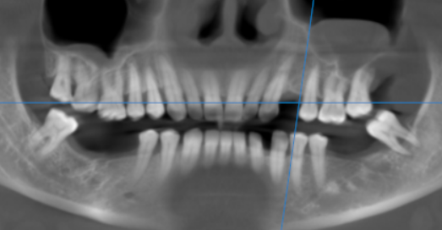

3-DIMENSIONAL VIEW

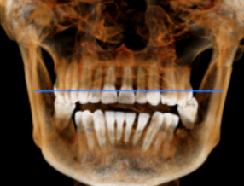

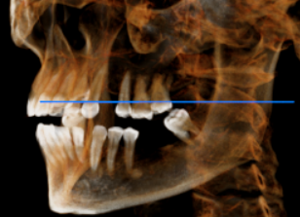

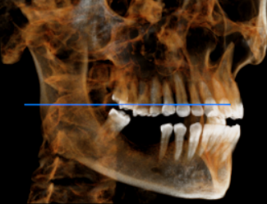

CROSS SECTIONAL VIEW

24 region | 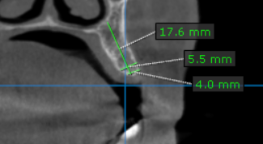
36 region | 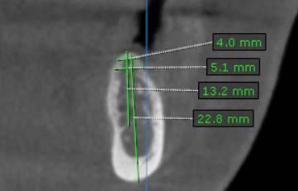
37 region | 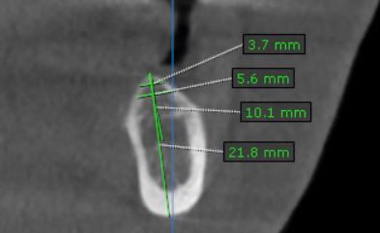
46 region | 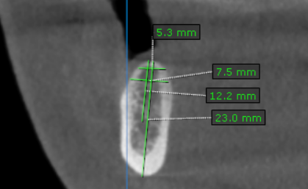
47 region | 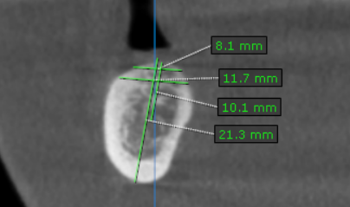

**** End of report ****

